IT24101466 Akeeth W.K.A.

PS Lab 9

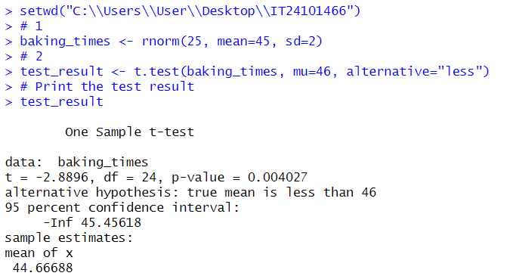

Interpretation:

Reject H0 and conclude the mean baking time is significantly less than 46 minutes.